Mar 12, 2026
The general setup of the system has previously been described in the latest document. Today’s challenge is to create baseline structure for the gas sensing setup, detect the baseline lock-in signal, laser beam focusing to ADM and finalizing electronic connections. Finally, I will try to produce linear signal depend on laser power or gas concentration.

Previously, gas connections re-established, laser focused to the ADM and loss has been calculated through two wedged windows. ADM have uncoated BaF2 windows with approximately 2.5 mm thickness*. The transmission data provided for 10 mm thick sample. To estimate the loss from the windows, few calculations conducted. Starting with Fresnel’s equations T=(1-R) where T is transmittance and R is reflectance. First, we need to find R by using data provided by Thorlabs. While R = ((n - n₁)/(n + n₁))² for normal incidence and n₁=1 for air, we need to find n₂ for BaF2. This can be calculated by using Sellmeier’s equation provided for our working wavelength:

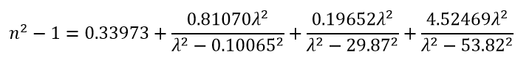
Fig_1: Sellmeier’s equation for BaF2. Retrieved from Thorlabs website*.

Since we have λ=7.7 μm, n=1.429. Now we can find the reflectance, which comes up as R≈0.0312 and hence T=1-R for Air-BaF2 interface is T≈0.9688. To account loss for both entrance and exit for the beam from the wedge window, we need to apply this equation twice. After finding the transmittance for interface, we need to calculate the bulk loss due to absorption. By using provided data, we can find absorption coefficient for the BaF2 by using Beer-Lambert law, exp(-$μ_{a}$d) where $μ_{a}$ is absorption coefficient of the BaF2 and d is the thickness of the sample. T_given=0.9207 for d=10 and for one wedge window. Now combining Fresnel’s equation with Beer-Lambert equation would yield:

T= (1-R)²exp(-$μ_{a}$d)
Solving for T_given=0.9207,R=0.0312 and d=10 mm gives $μ_{a}$≈0.001923 mm-1. Now we have everything to calculate T for our setup. For one wedge window with d=2.5 mm thickness is T≈0.9341. To account loss due to both input and output window, we need to apply it twice. Finally we have T_exp≈0.8725. Note that this value is wavelength specific. So during alignment, this amount of power loss is due to windows and acceptable. If input power is P_in=10 mW, output expected to be around P_out=8.7 mW. Since the beam operating at IR, this method is useful during alignment process.

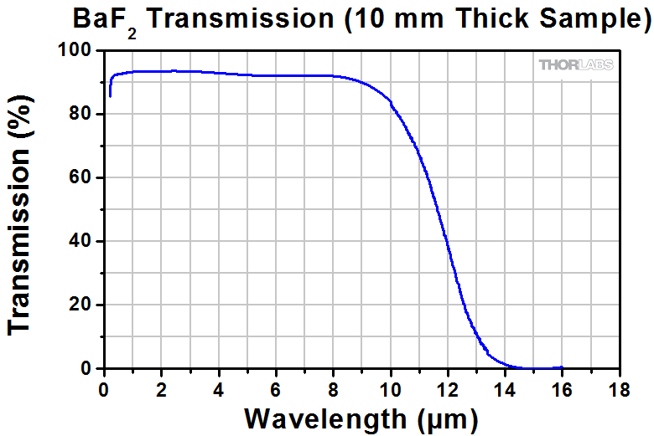
Fig_2: BaF2 transmission data from Thorlabs website*.

Next stage of the experiment is to drive QCL with an external trigger. Since it is an TTL input, I configured the waveform generator as shown in the Fig_3. High impedance, pulse mode, 5 Vpp amplitude with f=f_r=12458.8 Hz (see ADM Characterization). To check whether driving of the laser is successful, I connect the TRIG OUT channel of the QCL to the oscilloscope to see if it is producing a valid reference for Lock-In Amplifier. Note that it produces this signal only when the laser is firing. It sends a high voltage TTL signal when the laser is on and goes to 0 when the pulse ends. Its voltage level always 5V and pulse width also matches with the settings of the laser on the GUI.
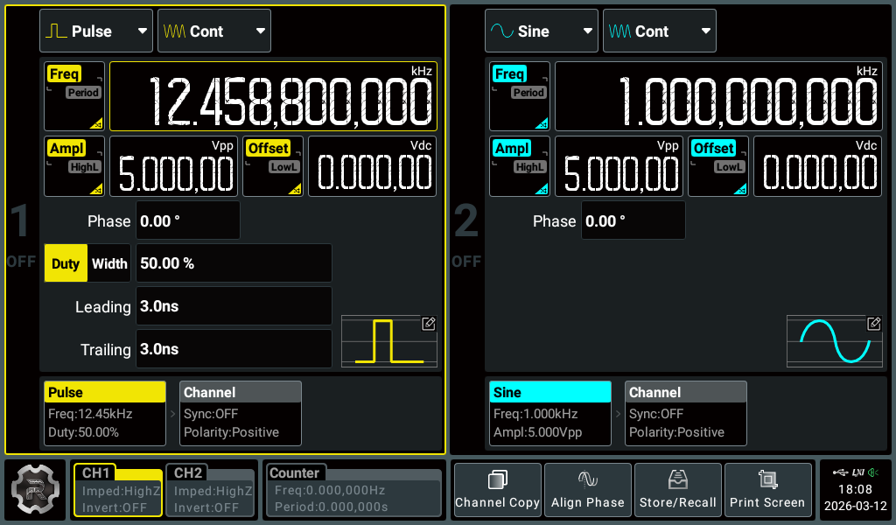
Fig_3: Waveform generator configuration for TRIG IN input of QCL to drive QCL with External Trigger Mode.

After verifying TRIG OUT channel is operating properly, next step is to connect this channel to EXT REF channel of the Lock-In Amplifier (LAI). When laser is firing and producing reference signal, UNLK indicator should not be lit. When the laser pulse width set below 400 ns, LAI fails to catch reference signal and fails to perform. To overcome this, I used WFG 2nd channel to produce a dummy-reference signal with the same phase and characteristic with the TRIG OUT channel, only pulse width is fixed and set to 500 ns. The dummy-reference signal should phase-matched before experimental procedures. The delay caused from the internal electronics of the QCL and phase-matched dummy-reference can be seen from the Fig_4.
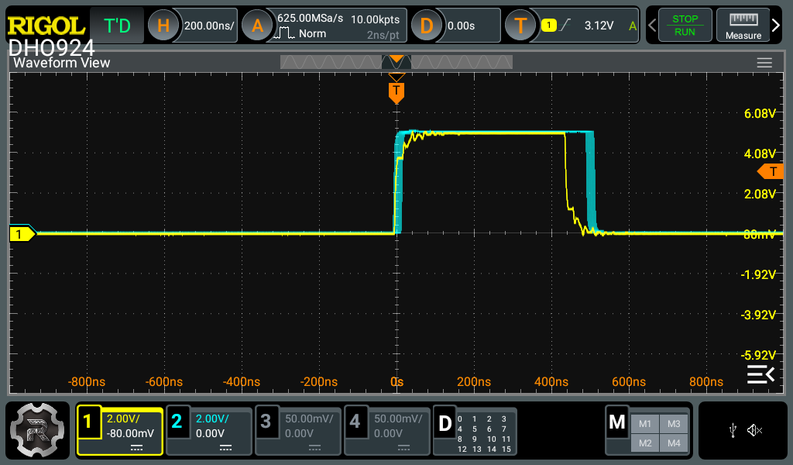
Fig_4: YELLOW(CH1): TRIG OUT channel of QCL. BLUE(CH2): Waveform generator dummy-reference, phase-matched with the CH1.

Fig_5 also shows the waveform generator configuration for both QCL driving signal and dummy-reference configuration.
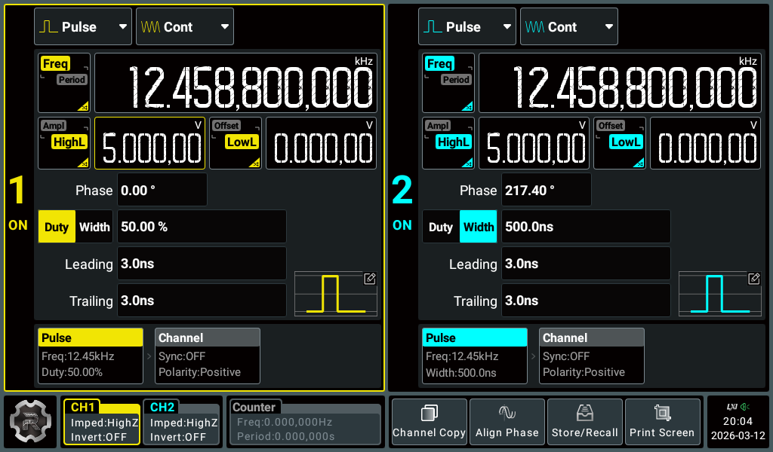
Fig_5: YELLOW (CH1): Trigger input for QCL’s TRIG IN channel. BLUE (CH2): Dummy-reference signal for LAI REF channel. Phase-matched with QCL TRIG OUT channel by setting phase=217.40 degrees.

Another important remark for LAI: its sensitivity configuration is somehow flawed. For sensitivity 50 mV, 5 mV and 500 μV. This configuration increases the output signal by 40% consistently and if it is not strictly necessary, usage of these channels should be avoided.

EXPERIMENTAL PROCEDURE

Today’s goal is to find a linear relationship between the power and output signal. For this reason, I use fixed N2O concentration. Currently we have two gases, 100% N2 and 100 ppm(0.01%) N2O. Final concentration can be found by:

C=$100×\frac{F_{N{2O}_{}^{}}}{F_{N2O}+F_{N2}} ppm$
where F is the flow rate of the gas. Today I used equal amounts of N2 and N2O and C=50 ppm.

Startingly, QCL output is set to p_w=500 ns and P_in=3.85 mW and P_out=3.15 mW for λ=7.7 μm. After applying T=0.8725 output should be equal to 3.35 mW, we have approximately 0.20 mW loss inside ADM, which is acceptable. We can assume the beam is focused according to the procedure that has been conducted before (See QCL Alignment).

Next step is to open gas vanes and set the mass flow rates accordingly, by using FlowVision v2.1.3 software on the computer. Pressure inside the chamber set to 600 Torr. Both flows set to 5 sccm to get 50 ppm. ADM’s electrical connections established. Vacuum pump opened and its output connected to fume hood.

To verify whether the signal coming from the ADM’s walls where laser is hitting or from the detected N2O, I set the wavelength to 1340 cm-1, where N2O has no absorption. This wavelength has produced output power of 3.18 mW. At this level, I read the LAI signal as V_signal=1.08 mV. After switching to the 1297.8 cm-1, power output increased slightly to 3.23 mW and signal to V_signal=1.52 mV. So, this can be evidence for there’s still some background noise from the misalignment of the laser, even the loss is 0.20 mW noise significantly high. I don’t know if this is standard for this system or this requires a further modification for the setup.

